Data How-To

Go to the link below.

<https://wiki.cancerimagingarchive.net/display/Public/CBIS-DDSM#83dd9b518d554b2983368fd0d778f31b>

Scroll Down

Go to Detailed Description

Scroll down

Pick the sub-section you want to download

You will download a JNLP file

Open it. You might have to update your java to open this file. It will open the TCIA Download Manger

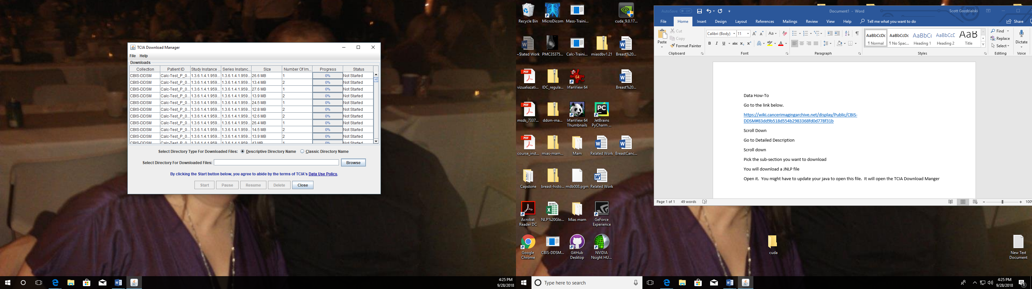

Select Browse and the file location. Then Start. You can stop the download at anytime and it will keep the complete files you did download. (Use Descriptive Directory Name.)

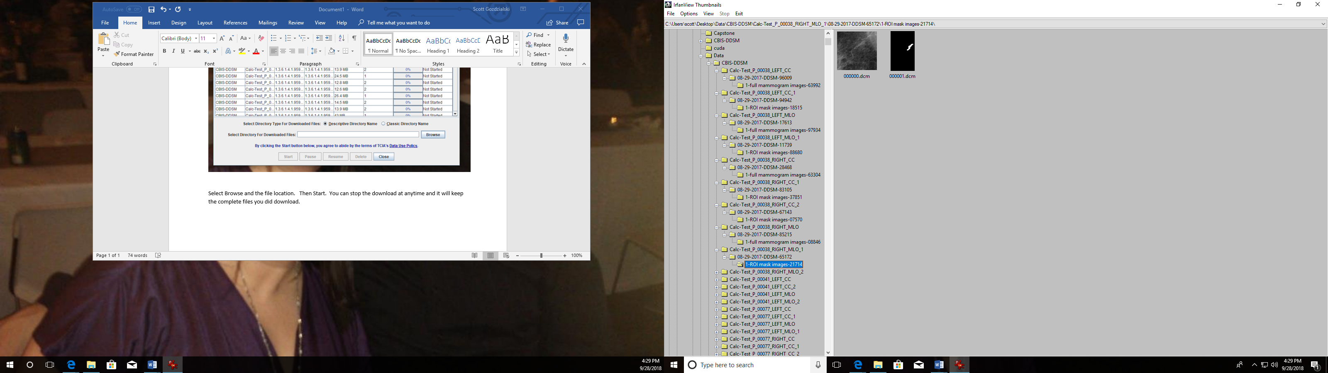

You will get a file system that is very confusing. Each subfolder has the images and they are all named the same. We need to find a way to give them a name based upon the folder structure they are in and in one location.

At this point we can use a program like Irfan View to convert the DCM files (used for medical imaging ) to Lossless JPGs.